Batho Ba Rona Supermarket — Network Design Documentation
CMPG 325 — Computer Networks | Project ID: CMPG325-2026-015 | Client ID: CLI-015
MILESTONE 2

- Default Route Configuration (BBR-EDGE-RTR)
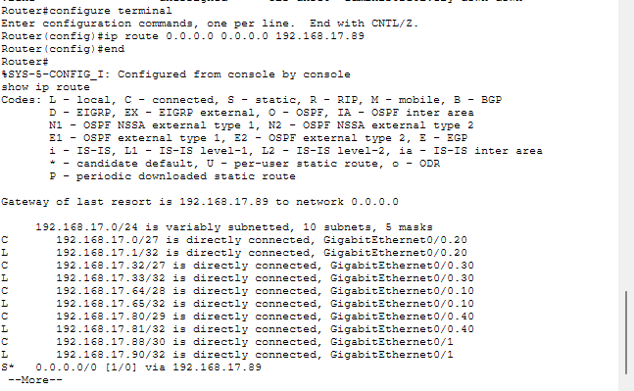
A static default route was configured on BBR-EDGE-RTR using the command ip route 0.0.0.0 0.0.0.0 192.168.17.89. The show ip route output shows the gateway of last resort set to 192.168.17.89 and the route marked S* as a static default route. A default route is appropriate because the supermarket has a single connection to the ISP, so all traffic that is not for the internal VLANs can use one next hop. It is simple to configure and maintain, which suits the client's limited IT support.
- Successful connectivity test between the edge router and ISP router
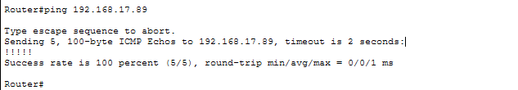
BBR-EDGE-RTR successfully pinged the ISP router at 192.168.17.89 with a 100% success rate (5/5), confirming the WAN link between the two routers is working.

- Traceroute verification from the edge router to the ISP router
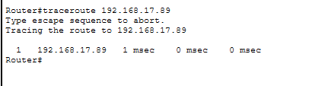
The traceroute from BBR-EDGE-RTR reaches 192.168.17.89 in a single hop, confirming the ISP router is directly reachable over the WAN link.

- POS end-to-end test to the ISP (POS-PC1 to 192.168.17.89)
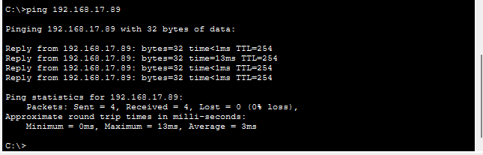POS-PC1 reached the ISP router at 192.168.17.89 through its gateway 192.168.17.65. The traceroute shows two hops, confirming traffic from VLAN 10 uses the default route to the ISP.
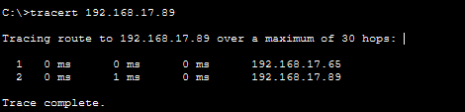

The traceroute shows the packet passing through the POS gateway (192.168.17.65) before reaching the ISP router (192.168.17.89).
- POS connectivity test (POS-PC1 to default gateway)
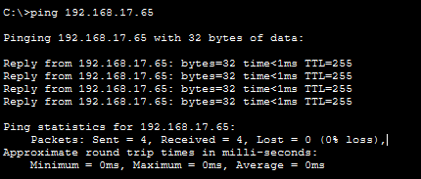
POS-PC1 successfully reached its default gateway 192.168.17.65 with 0% packet loss, confirming that VLAN 10 traffic reaches the edge router after the POS switch was reconnected.
- Admin VLAN end-to-end test (ADMIN-PC1 to 192.168.17.89)
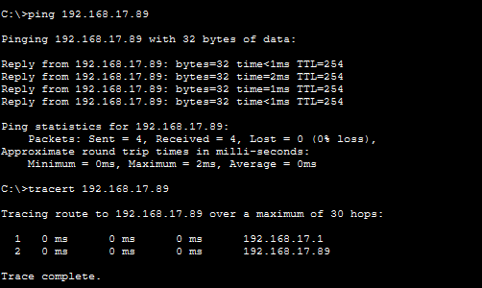
ADMIN-PC1 successfully pinged the ISP router at 192.168.17.89 with 0% packet loss. The traceroute shows two hops, through the Admin gateway (192.168.17.1) and then the ISP router, confirming that traffic from the Admin VLAN also uses the default route.
- Wi-Fi/Staff VLAN end-to-end test (STAFF-LAPTOP to 192.168.17.89)
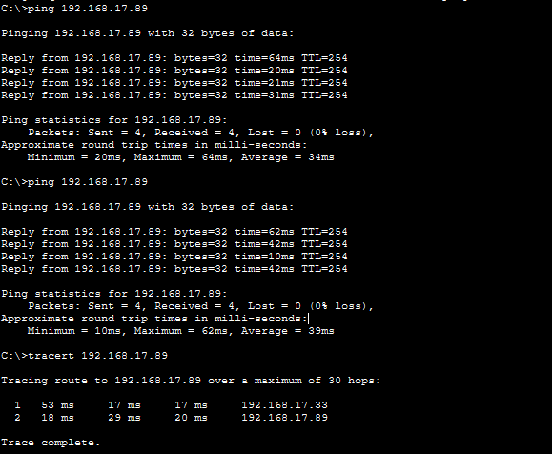
STAFF-LAPTOP, connected through BBR-AP, successfully pinged the ISP router at 192.168.17.89 with 0% packet loss. The traceroute shows two hops, through the Wi-Fi/Staff gateway (192.168.17.33) and then the ISP router, confirming that traffic from VLAN 30 also uses the default route.
- Configuration summary
BBR-EDGE-RTR
interface GigabitEthernet0/1
ip address 192.168.17.90 255.255.255.252
ip route 0.0.0.0 0.0.0.0 192.168.17.89

ISP-RTR
interface GigabitEthernet0/0
ip address 192.168.17.89 255.255.255.252
ip route 192.168.17.0 255.255.255.0 192.168.17.90
The full running configurations of BBR-EDGE-RTR and ISP-RTR are available in the configs folder of my GitHub repository.
- Troubleshooting performed
Issue 1 – POS switch disconnected: The cable between SW-POS and BBR-CORE-SW was lost, so the POS VLAN could not reach the edge router. I ran show interfaces status on both switches and found the unused trunk ports: Fa0/1 on SW-POS and Fa0/2 on BBR-CORE-SW. I reconnected the cable between these two ports and confirmed both showed connected as trunk ports.
Issue 2 – ISP router configuration: The first pings from the edge router to the ISP router failed until the ISP router's interface address and its return route to the 192.168.17.0/24 network were configured. After that, the ping succeeded.
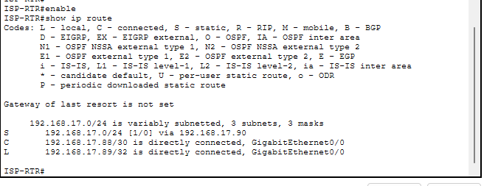

Issue 3 – First ping timeouts: The first ping after a link comes up sometimes times out (for example 0/5, then 4/5) while ARP resolves the neighbour's MAC address. Repeating the ping gave a 100% success rate.
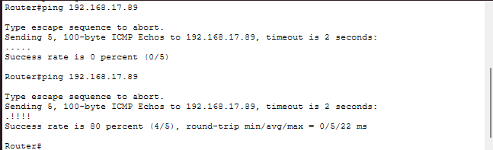
Issue 4 – Wi-Fi VLAN unreachable: STAFF-LAPTOP could not reach its gateway 192.168.17.33 or the ISP router because port Fa0/4 on BBR-CORE-SW, the link to SW-WIFI, was configured as an access port in VLAN 1 and did not carry VLAN 30. I ran show interfaces trunk and show cdp neighbors on the core switch to find the fault, then configured Fa0/4 as a trunk allowing VLAN 30. After this, the laptop reached the gateway and the ISP router with 0% packet loss.

